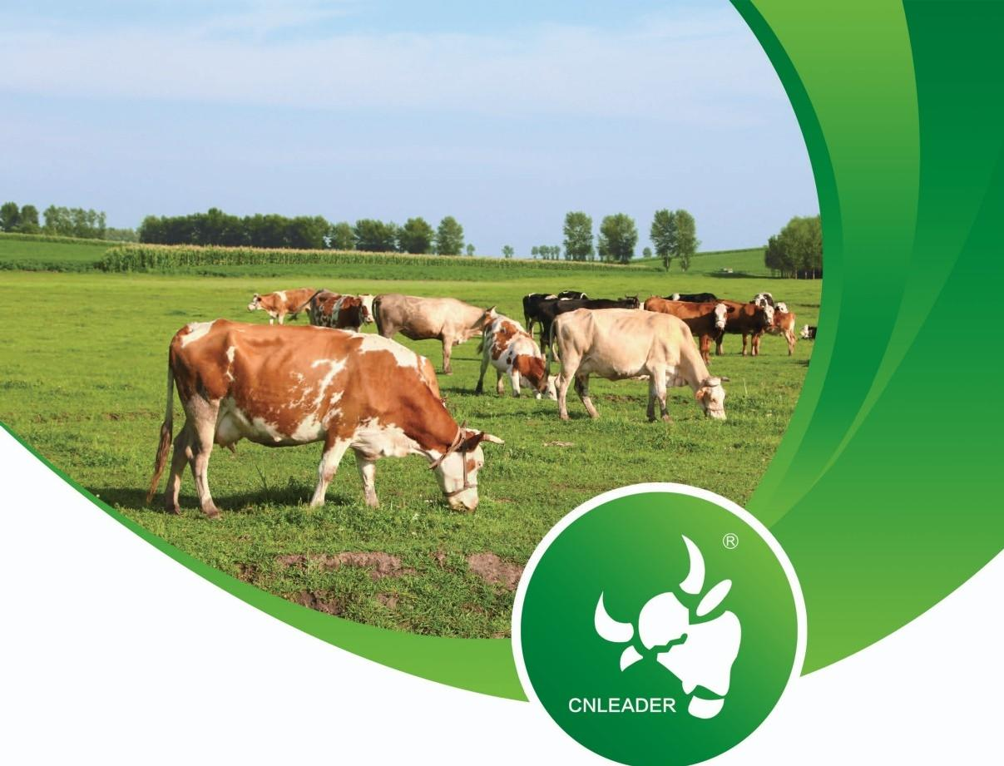

诚信利德尔

用心做好药
Honest Leader Dedicated to Quality Medicine

CNLEADER(HEBEI)
PHARMACEUTICAL CO.LTD INTRODUCTION



About us
关于我们
Company honor
企业资质
Product introduction
产品介绍
Join us
加入我们

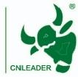

Honest Leader
Dedicated to Quality Medicine


CNleader(Hebei)Pharmaceutical Co.Ltd.was established in June 2005.The company is covering an area of over 30 acres with a registered capital of 50 million yuan.It boasts high-standard,automated veterinary drug production workshops that have passed the new GMP certification,including powder/premix,powder,oral solution(with traditional Chinese medicine extraction),liquid disinfectant,and other dosage forms.Additionally,it has multiple feed additive production workshops, including mixed feed additives,premixed feed (solid and liquid),microecological additives,and fermentation workshops,all certified under the ISO9001 quality man- agement system and ISO14001 environmental management system.In 2020,the company invested in the construction of a fully automated 84 disinfectant produc-
tion workshop and amodern R&D center certified as a Class A industrial enterprise research institution by the Hebei Provincial Department of Industry and Information Technology.

CNLEADER(HEBEI)PHARMACEUTICAL CO.LTD 01 INTRODuCTION
INTRODUCTION

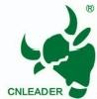

Honest Leader
Dedicated to Quality Medicine

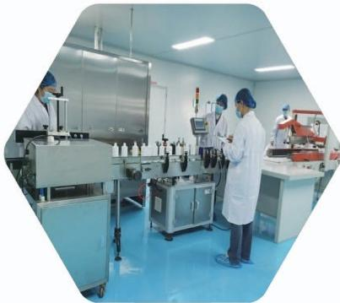
corporate values
企业价值观
For years,CNleader has upheld the corporate tenet of "Integrity,Responsibility,Passion,
Innovation,"continuously advancing and striving for excel- lence. Meanwhile the company has humanistic care.

The company has been honored with titles such as "High-
Tech Enterprise,""Technology-Based SME,""Innovative
Enterprise,""Hebei Integrity Enterprise,"and "Model Unit in
Combating Hebei Flood Disasters."It also serves as the
chairman unit of the Traditional Chinese Veterinary Medicine Branch of the Hebei Animal Husbandry and Veterinary Society, vice chairman unit of the Animal Immunology Branch,execu- tive council member of the Hebei Animal Health Association,
and council member of the Hebei Feed Technology Industry Innovation Alliance.
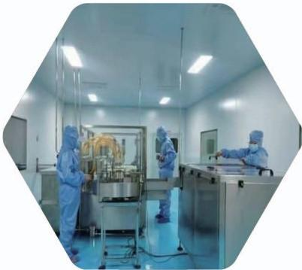
pursues a high-quality product strategy
精品化路线
Through long-term cooperation and technological devel-
opment with research institutions such as China Agricul- tural University,Nanjing Agricultural University,Hebei
Agricultural University,Hebei University of Science and Technology,the Chinese Academy of Agricultural
Sciences,the Hebei Academy of Sciences,and the Uni- versity of Illinois(USA),Lidel has successfully developed premium products which earning widespread recognition
from major domestic farming groups

n response to the national demand for antibiotic-free healthy breeding,the company has intensified R&D efforts in probiotics, fermented traditional Chinese medicine,and immune enhanc- ers,achieving remarkable results.

02

CNLEADER(HEBEI)PHARMACEUTICAL CO.LTD
INTRODUCTION

ENTERPRISE HONOR 企业荣誉
Including:Veterinary Drug Production License&Feed Production License&Feed Additive Production Liscense
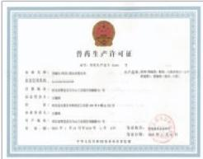
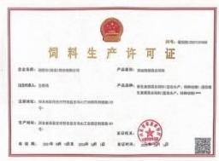
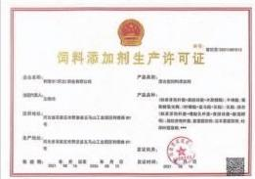
1
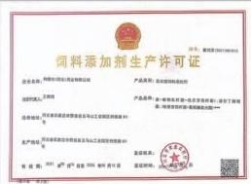
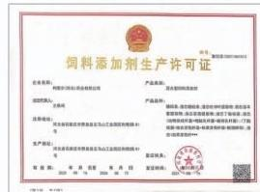

Including:Quality Management System Certificate&Environmental Management System Certificate&GMP for Animal Drugs Certificate

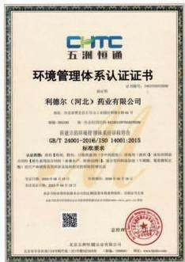
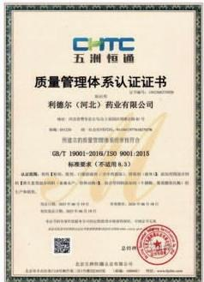
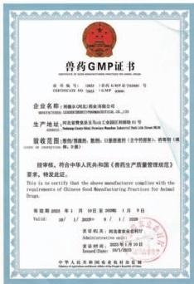

CNLEADER(HEBEI)PHARMACEUTICAL CO.LTD 02
INTRODUCTION

Innovative Enterprise,""Hebei Integrity Enterprise,"and "Model Unit in Combating Hebei Flood Disasters."It also serves as the chairman unit of the Traditional
Chinese Veterinary Medicine Branch of the Hebei Animal Husbandry and Veteri- nary Society,vice chairman unit of the Animal Immunology Branch, executive
council member of the Hebei Animal Health Association,and council member of the Hebei Feed Technology Industry Innovation Alliance.

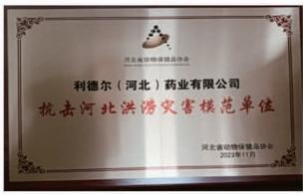
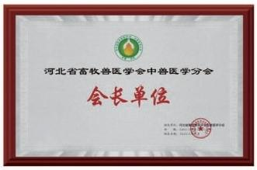
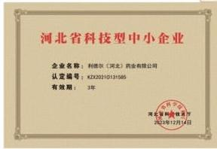
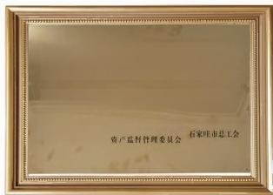

石家庄市创新型企业
企业名称：利德尔(河北)药业有限公司
石家庄市人民政府国有 石家庄市科字技术局
二0二0年十二月
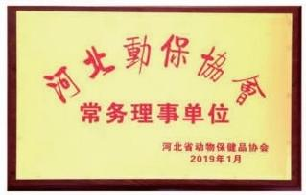

CNLEADER(HEBEI)PHARMACEUTICAL CO.LTD
INTRODUCTION

Product Introduction
产品介绍
Vitamins 维他命类



D | A | B₁  B₂  D
 | B,

主要功能：增强免疫力、预防疾病、保肝护肾
Main functions:Enhance immunity,prevent diseases, protect the liver and kidneys

INTRRUODDUCClITUIN

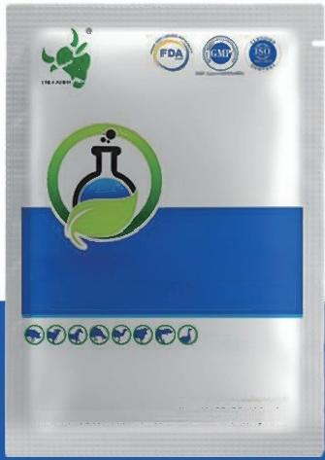

Vitamin AD₃E Powder

1000g

www.CMLEADER,COM.CN
Leader(Hebei)Pharmaceutical Com.,Ltd

This product promotes the growth and development of livestock and poultry.Supplement deficiencies of vitamin AD3 and Ein the diet of livestock and poultry Build up resistance and improves the function of the reproductive system.Prevents rickets,dysplasia and soft egg,egg-shaped decrescent,rate decline and So on Stimulates antibody productions and helps
vaccines to function well.Acts as best anti stress agent.

06

CNLEADER(HEBEI)PHARMACEUTICAL CO.LTD
INTRODUCTION

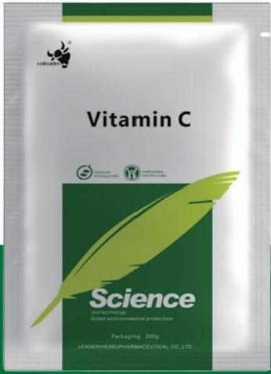

This product can supplement the animal's need for vitamin C,enhance the animal's anti-stress and anti-infection ability,promote the absorption of trace elements,promote the synthesis of amino acids,and promote the metabolism of toxins in the body.

CNLEADER(HEBEI)PHARMACEUTICAL CO.LTD 07 INTRODICTION
INTRODUCTION

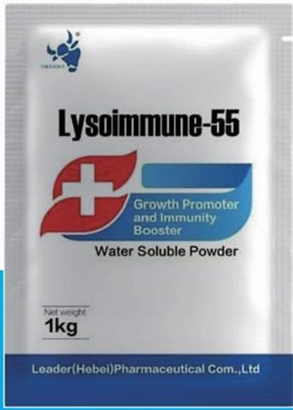

It is animmunemodulator that helps to strengthen bird's generalimmune system.It increases the bird's growth rate,FCR and reduces the need of medication. It increases immunity by repairing issues,improves egg production and weight gain inpoultry.

08

CNLEADER(HEBEI)PHARMACEUTICAL CO.LTD
INTRODUCTION

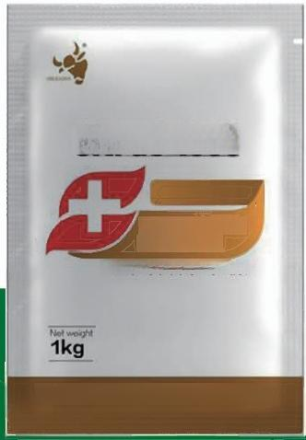

UItraC-1000

Feed Additive
for Poultry
Water Soluble Powder

Leader(Hebei)Pharmaceutical Com.,Ltd

Used to eliminate vitaminC deficiency in animals. Increases the productivity and reproductive perfor- mance of animal.Indispensable component for healthy development,teeth,bonesandskin.Eliminates the decrease in vitaminC synthesisat high temperature sand season-alchanges.

INTRODUCTION

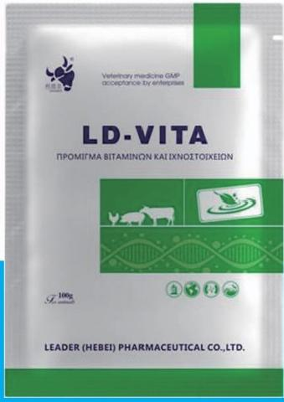

Growth Promotion
Compensate for vitamin deficiencies in feed to improve growth rate
Key components:Vit A/D/E+B-complex(B1/B2/B12) Reproductive Performance

10INTRODUCT(HIONEI)PHARMACEUTICAL CO.LTD

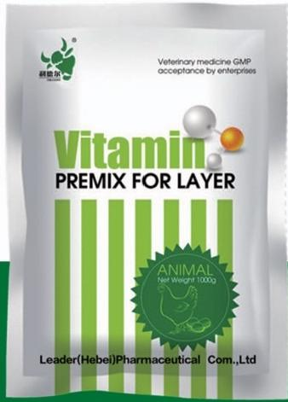

Egg Production Enhancement
Enhances Ca/P absorption for ovulation Protects ovarian cell membranes
Supports nucleic acid synthesis
Eggshell Quality Regulates calbindin synthesis

CNLEADER(HEBEI)PHARMACEUTICAL CO.LTD 11 INTRODUCTION I

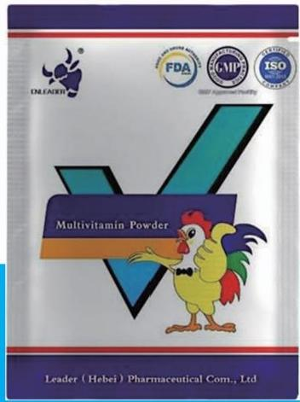

Improve animal and poultry growth,production and development.Aids to reduce the stress and acts as a supportive therapy in various fattening,infectious and parasitic discase.Helps in the prevention of hypo and avitaminosis,degenerative myopathy,dystrophy of the liver,rickets,osteomalacia,tetany,keratitis,night sight,sterility in females and convalescence。

12

CNLEADER(HEBEI)PHARMACEUTICAL CO.LTD
INTRODUCTION

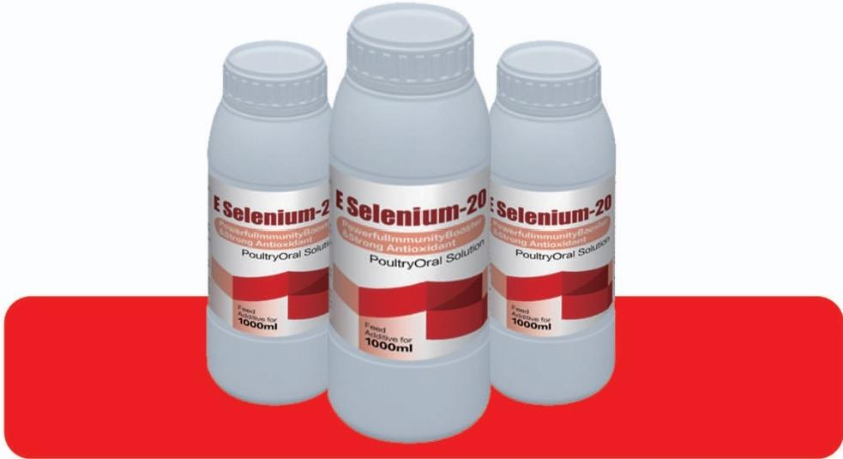

Strengthens the immune system and increases body resistance through the antioxidant effect that occurs when selenium and vitaminE act together Prevents problems such as liver
deterioration,encephalomalacia,exudativedie thesis and white muscle issues or is used as asupportive treatment during there covery period.

CNLEADER(HEBEI)PHARMACEUTICAL CO.LTD 13 INTRODUCTION
IINTRUDU lIOIN

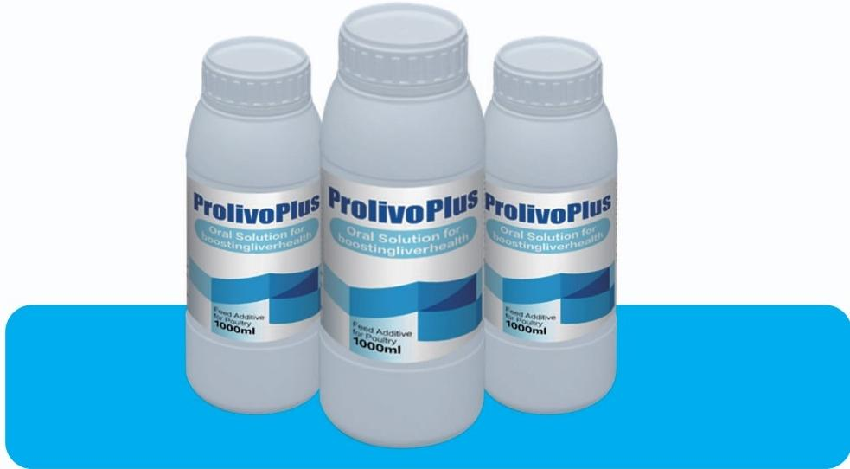

Enhance the immunity and protect the liveraga
instliver related diseases.ProlivoPlusis recom-
mended in period of stress duet of attyliver
syndrome,hepatorenaldys functioning,mycotoxico- sis and metabolicdis orders.Helpsintherepairing of damaged livert issue.

14

CNLEADER(HEBEI)PHARMACEUTICAL CO.LTD
INTRODUCTION

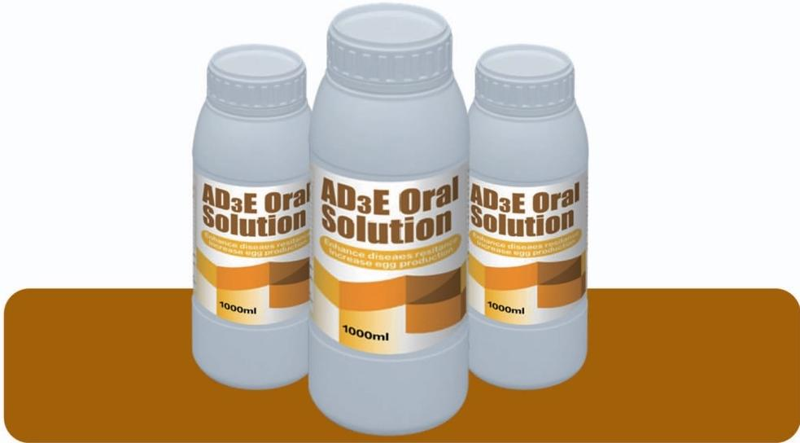

Supplement the deficiency of vitamins in animals, protect the liver,enhance immunity,promote animal growth and reduce the growth of diseases.



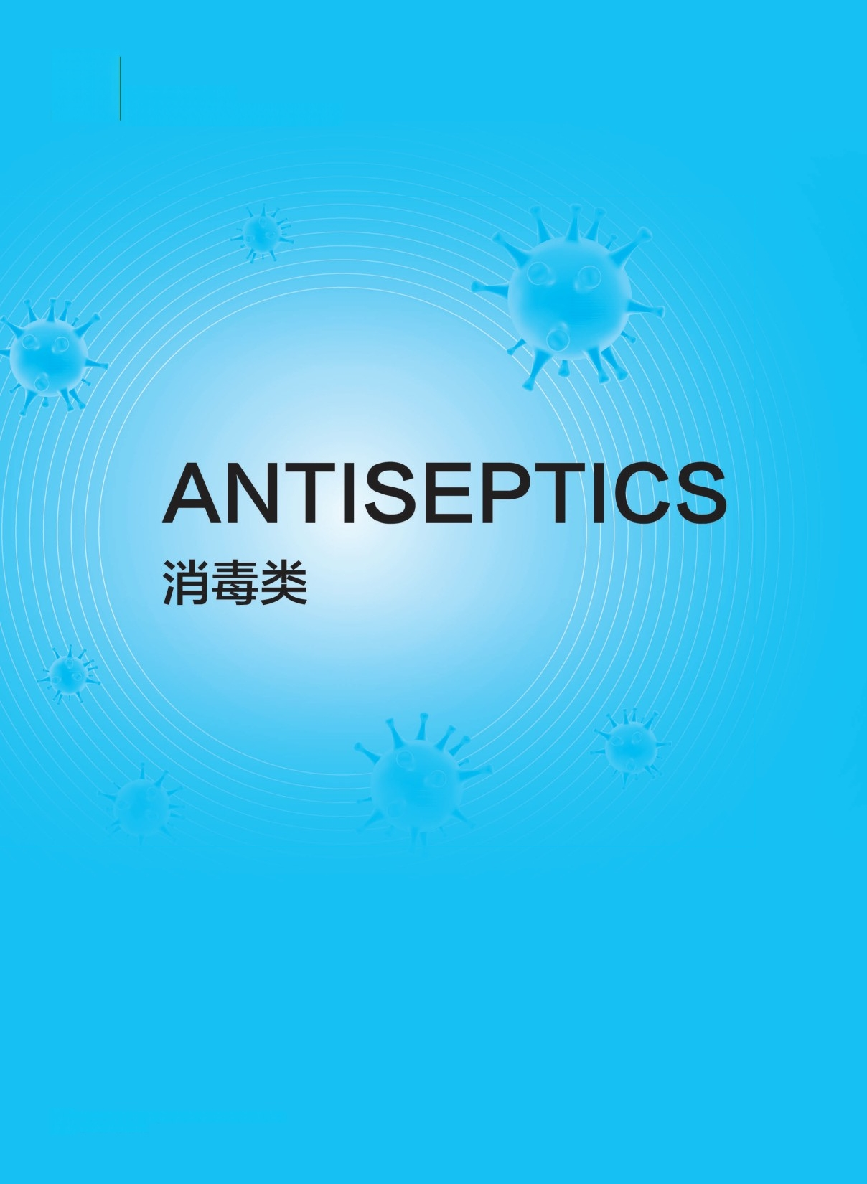
Honest Leader
Dedicated to Quality Medicine

CNLEADER(HEBEI)PHARMACEUTICAL CO.LTD INTRODUCTION
16

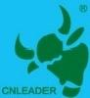


Honest Leader
Dedicated to Quality Medicine

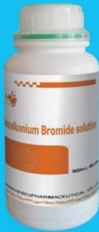
Function and Use:Antiseptic.
Used for surgical instruments,skin and wound disinfection.

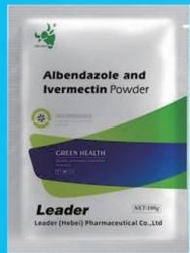
Function and use:A dewormer. Used to remove or kill animals nematodes,flukes,tapeworms, mites and other internal and
external parasites.
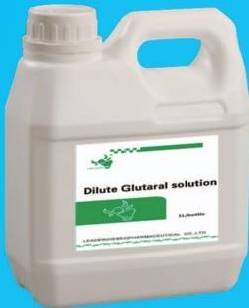
It is mainly used for deworming
animals and promoting the growth and health of animals.

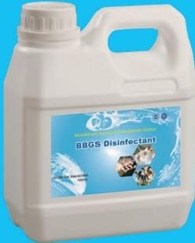
Function and use:Aldehyde anti- septic.Used to disinfect rubber, plastic products,surgical instru- ments and stables.

CINTRODUCHIONEI)PHARMACEUTICAL CO.LTD 17

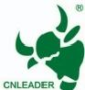

Honest Leader
Dedicated to Quality Medicine
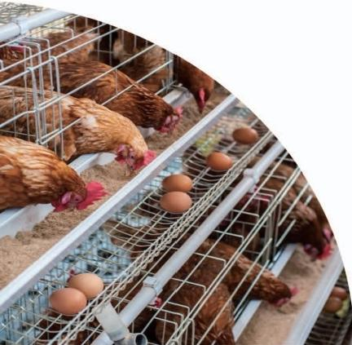


SPEXTRUM ANTIBIOSIS 光谱抗菌
Leader(Hebei)Pharmaceutical Com.,Ltd
Whatsapp/tel/wechat:+8613623305553Emailadmin@cnleader.cn

Serial  number | Product name | content
1 | Enrofloxacin powder | 10%
2 | Neomycin sulfate powder | 5%、10%
3 | Doxycycline hydrochloride soluble powder | 5%、50%
4 | Erythromycin thiocyanate soluble powder | 5%
5 | Sodium sulfamide chlorpyrazine soluble powder | 30%
6 | Amprimycin sulfate soluble powder | 10%
7 | Daguanomycin hydrochloride lincomycin hydrochloride soluble powder | 20%、40%
8 | Dihydropyridine premix | 5%
9 | Compound sulfamethoxil soluble powder | 8.3%+1.7%
10 | Colistin sulfate soluble powder | 10%
11 | Amoxicillin soluble powder | 10%、30%
12 | Oxytetracycline hydrochloride soluble powder | 10%、50%
13 | Neomycin sulfate soluble powder | 32.5%
14 | Carbapyrine calcium powder | 50%
15 | Flufenicol powder | 10%、20%
16 | Timicosin premix | 10%、20%
17 | Flufenicol solution | 10%
18 | Diczulil solution | 0.5%
19 | Enrofloxacin solution | 10%
20 | Povidone-iodine solution | 5%、10%
21 | Dilute glutaraldehyde solution | 2%、5%
22 | Benzalammonium bromide solution | 5%
23 | liquor iodi fortis | 5%、10%
24 | Solution of trimethylbenzylammonium chloride | 100%
25 | Albendazole ivermectin powder | 10%+0.2%
26 | Vitamin C soluble powder | 6%
27 | Amoxicillin+clavulanic acid | 10%+2.5%

18

CNLEADER(HEBEI)PHARMACEUTICAL CO.LTD
INTRODUCTION

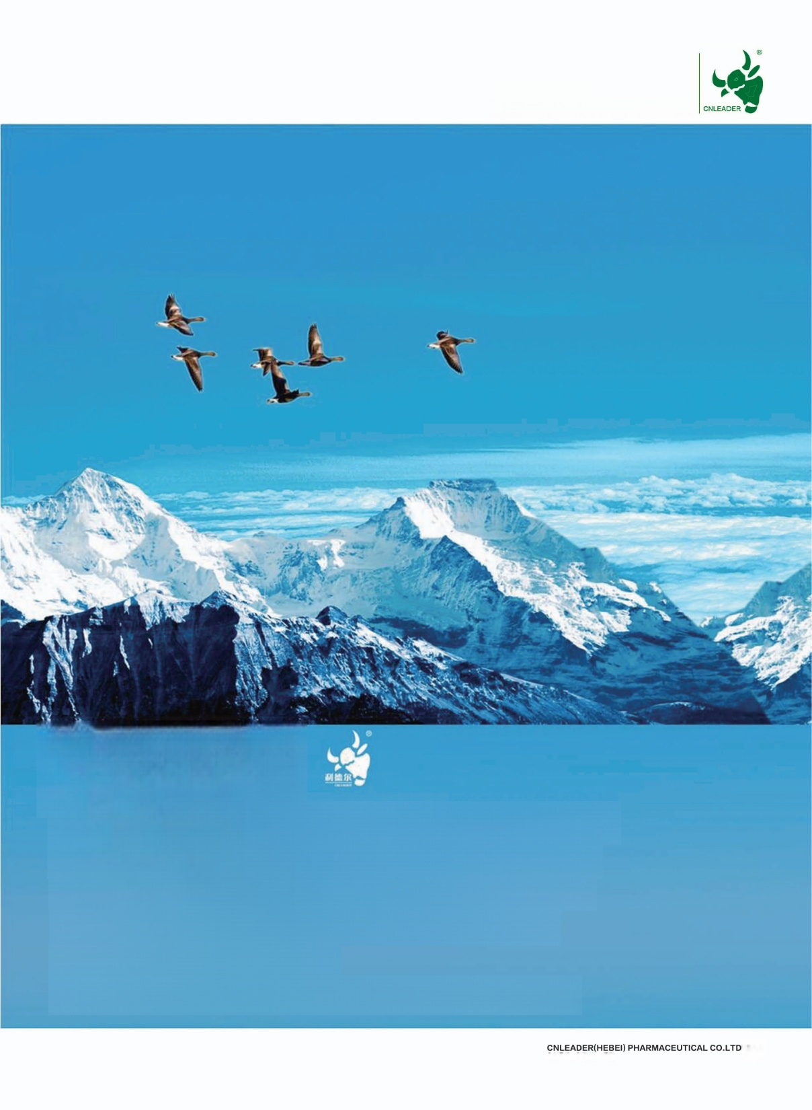
Honest Leader
Dedicated to Quality Medicine

JOIN US
Leader Pharma.insist on Producing a product,establishing a brand,developing a market.After10 years of development, with superior products and good service, the company has become the most development potential of large-scale
integrated enterprise in China.
We believe that LEADER is more colorful because of you!

INTRODUCTION 19

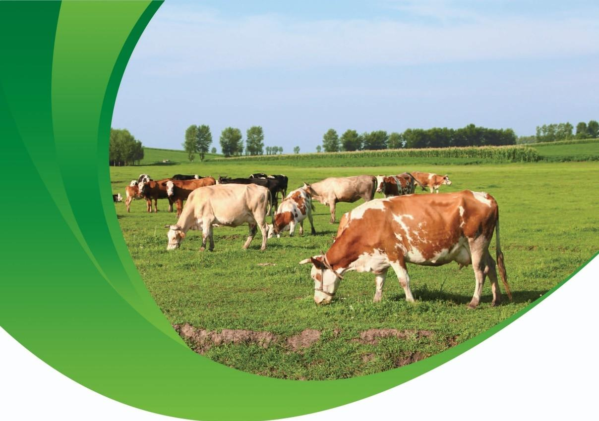

CNLEADER(HEBEI)
PHARMACEUTICAL CO.LTD INTRODUCTION
HTTPS://WWW.CNLEADER.CN
E-MAIL:ADMIAN@CNLEADER.CN

